**Analysis of the Correlation of Movie Ratings on Movie Revenue.**

Results of Analysis

**A: Project Highlights**

What correlation exists between a movie’s revenue and user ratings? Do more highly rated movies make more money? This analysis aims to identify if such a correlation exists and to what extent it affects revenue.

This project’s scope includes gathering, cleaning, and exploring two source datasets to identify relationships between movie revenue and numerical user ratings. The method used to identify correlation will be the Scipy Stats library, which will identify any correlation and probability for each year over a ten-year period from 2006 to 2016. Given the results over this period, the range was also expanded to a thirty-year period, from 1986 to 2016, with similar results.

This project will not include analysis of other impact factors such as professional critic ratings, movie genre, box office distribution, or any other unidentified factor. The datasets initially selected for this analysis shall not be expanded upon after the commencement of this project. Any further analysis identified herein should be pursued in a follow-up project.

The tools used to perform this analysis included Pycharm and Jupyter Notebooks using Python code. Libraries to be utilized in this analysis shall include Pandas, Scipy, Matplotlib, datetime, JSON, requests, and os. Additional libraries may be included, as necessary.

**B: Project Execution**

The goal is to identify if any statistical significance exists between user ratings and movie revenue.

The project objective is to determine the correlation and probability between a movie’s user ratings and revenue and identify any year-over-year trends.

Deliverables include the specific correlation and P value for movie revenue vs. user ratings for each year in the sample over the initial sample period, 2006 to 2016. Deliverables include a scatterplot and two bar charts for each year in the sample. The scatterplot compares revenue and average user rating for each movie release during the given year. For the bar charts per year, one chart lists the top ten movies by total revenue, and the other lists the top ten movies by top user ratings. Both charts include the percentage ranking of each of the included movie’s total revenue and user rating.

The correlation values and P values numerically identify the correlation and likelihood for our hypothesis while the various charts visually demonstrate the discovered relationships.

The methodology for the implementation of this project is ADDIE.

* The analysis phase included the gathering and exploration of the selected datasets for this project.
* The Design phase included the identification of required data and planning of the steps necessary to convert the original dataset(s) into useful data. This phase also included the identification of the hypothesis and null hypothesis for this project.
* The Development phase includes the required data cleaning, data conversion, and joining of datasets to create a single dataset for analysis, as well as the writing of the code necessary to implement the methods to assess the correlation coefficients, P values, and sample size data for each year’s movies.
* The Implementation phase included the implementation of created methods to capture the data required for this project. This phase will also include the creation of the scatterplots and bar charts per year.
* The evaluation phase included the review of analysis results to determine whether the hypothesis or null hypothesis was found correct.

Project Timeline:

| **Milestone or Deliverable** | **Duration** | **Start Date** | **End date** |
| --- | --- | --- | --- |
| Cleaned, joined dataset ready for analysis | 2 days | 12/1/2024 | 12/3/2024 |
| Availability of classes and methods to assess correlation coefficients, P_values, sample data per year, and related plots. | 2 days | 12/3/2024 | 12/5/2024 |
| Availability of analysis results and required plots. | 1 day | 12/5/2024 | 12/6/2024 |
| Analysis of project results. | 2 days | 12/6/2024 | 12/8/2024 |

**C: Data Collection Process**

Two source datasets were found to facilitate the analysis of relationships between movie revenue and user ratings. These are the same datasets identified in the project proposal.

1. The Revenue dataset:

From OpenML: Detailed movie descriptions - ideal for Recommendation Engines Website: <https://www.openml.org/search?type=data&status=active&id=43113> Link to data: <https://www.openml.org/data/download/22047889/dataset>

The Revenue dataset will be collected programmatically using the download link: <https://www.openml.org/data/download/22047889/dataset> and stored locally.

1. The Review dataset:

From OpenML: This dataset contains IMDb ratings and votes information for movies having original titles. Website: <https://www.openml.org/search?type=data&sort=runs&id=43784&status=active> Link to data: <https://www.openml.org/data/download/22102609/dataset>

The Review dataset has been downloaded using the OpenML download link: <https://www.openml.org/data/download/22102609/dataset> and stored locally.

One obstacle was found during the data-gathering process. During the import of the source data into working data frames, errors were found when importing a small portion of the total rows from the source CSV files. These include 67 rows from the Revenue dataset which included 4715 rows originally which comes out to 1.4% of the source dataset not being included. Similarly, the Review data frame, which contained 67408 rows of data, included 1824 rows of data that could not be imported from the CSV file which comes out to 2.7%. These rows of data were not included in the analysis and a ‘bad_line_logger’ function was created to capture for future reference if necessary. The remaining data was determined to be sufficient for this examination of the relationship between movie revenue and user ratings. No other obstacles were encountered.

Regarding unplanned data governance issues, given the project’s scope, public domain source datasets, and lack of confidential information, no unexpected issues were encountered.

**C1: Advantages and Limitations of Data Set**

An advantage of the source datasets is their small size specifically related to the number of columns in the datasets. The Review dataset contains only 5 columns of data which keeps the cleaning of the data frame to a minimum regarding data types and removal of unnecessary data. The Revenue data frame contains 10 columns of data which remains very manageable. While there are other datasets available from which to perform this examination, those datasets include much data that is not useful to the analysis given the specific scope of this project.

One disadvantage of these datasets is the lack of additional columns which, while not useful per this project’s scope, could provide insights during this analysis that could lead researchers to other more relevant factors related to movie revenue to investigate in future projects. In this case, the small size of the source datasets could be both an advantage and a potential disadvantage.

Another disadvantage of the source datasets is the lack of specific sources of a movie’s revenue such as box office opening revenue, revenue from streaming services, etc. The breakdown of the total revenue into these sources could provide greater insight into the relationship of user ratings related to these specific sources of a movie’s revenue.

**D: Data Extraction and Preparation**

Data preparation was performed as anticipated with little deviation from the cleaning steps identified in the project proposal, except for the import from CSV process.

During the import of the source data into working data frames, errors were found when importing a small portion of the total rows from the source CSV files. These include 67 rows from the Revenue dataset which included 4715 rows originally which comes out to 1.4% of the source dataset not being included. Similarly, the Review data frame, which contained 67408 rows of data, included 1824 rows of data that could not be imported from the CSV file which comes out to 2.7%. These rows of data were not included in the analysis and a ‘bad_line_logger’ function was created to capture for future reference if necessary. The remaining data was determined to be sufficient for this examination of the relationship between movie revenue and user ratings. The remaining processing steps were performed with no unexpected issues.

These datasets contained more information than necessary to prove the hypothesis regarding movie revenue and ratings. The only needed columns were the “id,” “title,” “original_title,” “revenue”, “review”, and “averageRating”. The inclusion of the remaining fields could negatively impact the readability of the cleaned and joined datasets so these unnecessary columns were removed.

The data types for the “revenue” and “averageRating” columns were imported as strings; however, these fields needed to be a “float”. Due to inconsistency in the source data, I had to import all fields as strings. The data types for the “revenue” and “averageRating” columns were converted into floats using the “.astype()” function.

The Revenue dataset had 1396 rows with '0' revenue listed. As these rows do not contain information useful to proving the hypothesis, these rows were remove.

The Review dataset contained many average ratings based on relatively few reviews. The minimum number of user ratings required to include the average user rating in this analysis has been set to five hundred. Any rows with less than five hundred reviews contributing to the average rating have been removed.

In the Revenue dataset, there were two columns containing movie title data: the “title” column and the “original_title” column. The "original_title" column has been removed as it contains alternate titles, includes special characters, and does not match the title data in the Review dataset. The movie Revenue dataset’s ‘title” column does match the Review dataset’s “title” column and was useful in this analysis.

**E: Data Analysis Process**

**E1 Data Analysis Methods**

The P-value and correlation coefficients were identified using “scipy.stats.pearsonr” comparing movie revenue and user ratings. A function was developed to filter the cleaned and joined datasets by year. SciPy’s Pearsonr function was then applied to this filtered dataset to calculate the correlation coefficient and p_value for the year. Code was also implemented in this function to create a scatterplot and two bar charts to visually demonstrate any relationship. The bar charts each list the top ten movies with one chart sorted by user ratings and the other by revenue. Both charts show the total revenue and user ratings per movie. A call applying this function over a range of ten years then provided the data required for evaluation of the null hypothesis.

Given the size and content of the joined working data frame, the Pearsonr function is appropriate for calculating the correlation coefficient and P value for each year in the sampled year range; 2006 to 2016.

**E2 Advantages and Limitations**

One advantage of this Scipy Stats Pearsonr is its ease of use. This function requires only the source data series and returns the correlation coefficient and P value.

One limitation of this tool is that it is limited to extrapolation of linear relationships. Should the data have been more complex, being limited to a linear relationship may not have been appropriate. For the needs of this analysis, Pearsonr is ideal.

**E3 Application of Analytical Methods**

A function was developed to filter the cleaned and joined datasets by year. SciPy’s Pearsonr function was then applied to this filtered dataset to calculate the correlation coefficient and p_value for a given year.

To visually demonstrate any relationship, this function also contains code to create a scatterplot and two bar charts. The bar charts each list the top ten movies with one chart sorted by user ratings and the other by revenue. Both charts show the total revenue and user ratings per movie. A call applying this function over a range of ten years then provided the data required for evaluation of the null hypothesis.

The correlation coefficient, P value, and sample size for each year in the sampled ten-year period from 2006 to 2016 are also recorded and plotted to identify any trends in these features over the sample period.

To further identify trends in these features one additional run was performed including data over a thirty-year period from 1986 to 2016.

Verification of the functions was performed over several iterations during the development of the code until repeatable results were achieved.

**F Data Analysis Results**

**F1 Statistical Significance (or Model)**

Null Hypothesis: Higher user ratings do not correlate with high movie revenue.

Alternate Hypothesis: Higher user ratings correlate with high movie revenue.

The Alpha value has been set to 0.05.

There is sufficient evidence to accept the null hypothesis and reject the claim that higher user ratings correlate with higher movie revenue.

The results of this analysis identified a weak average correlation of 0.207 between movie revenue and user ratings. The average is calculated using correlation coefficients calculated for the movies released in each year in the ten-year sample, from 2006 to 2016.

A “get_corr_coef_data_year_range(start_year, end_year)” function was created to identify various statistics for the sampled year range. For the years 2006 to 2016, the results are as follows:

Year Range: 2006 to 2016

Average Correlation Coefficient: 0.207

Min Correlation Coefficient: -0.213

Max Correlation Coefficient: 0.573

Average P Value: 0.401

Min P Value: 0.007

Max P Value: 0.918

Average Yearly Sample Size: 25

Min Yearly Sample Size: 9

Max Yearly Sample Size: 57

Total Samples (All Years in Year Range): 272

The following charts are also created to identify trends in correlation coefficients, probability, and sample sizes over the ten-year period.

Regarding P Values for the sampled years, a Python dictionary was created and populated as part of the “get_corr_coef_data_year_range(start_year, end_year)” function. The results for this sample period are as follows:

For 2006 the P value is 0.147.

For 2007 the P value is 0.485.

For 2008 the P value is 0.668.

For 2009 the P value is 0.319.

For 2010 the P value is 0.466.

For 2011 the P value is 0.275.

For 2012 the P value is 0.007.

For 2013 the P value is 0.579.

For 2014 the P value is 0.918.

For 2015 the P value is 0.020.

For 2016 the P value is 0.530.

Only two of the ten years have a P value indicating a high likelihood of the Null Hypothesis being incorrect; however, the average for the ten-year period does not support this conclusion.

For each year of the sampled period, we have plotted the revenue and user ratings for the top ten movies by Revenue and Rating. The results for each individual year are as follows:

Year: 2006

Sample size 11

Correlation Coefficient: 0.467, P Value: 0.147

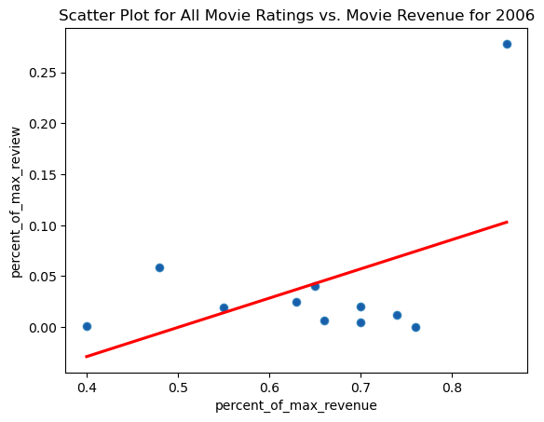

Year: 2007

Sample size 9

Correlation Coefficient: 0.268, P Value: 0.485

Year: 2008

Sample size 26

Correlation Coefficient: 0.088, P Value: 0.668

Year: 2009

Sample size 57

Correlation Coefficient: 0.134, P Value: 0.319

Year: 2011

Sample size 35

Correlation Coefficient: 0.190, P Value: 0.275

Year: 2012

Sample size 23

Correlation Coefficient: 0.548, P Value: 0.007

Year: 2013

Sample size 18

Correlation Coefficient: 0.140, P Value: 0.579

Year: 2014

Sample size 16

Correlation Coefficient: -0.028, P Value: 0.918

Year: 2015

Sample size 16

Correlation Coefficient: 0.573, P Value: 0.020

Year: 2016

Sample size 11

Correlation Coefficient: -0.213, P Value: 0.530

Given the results of the analysis of the original ten-year period, from 2006 to 2016, a broader analysis of trends was performed over a thirty-year period, from 1986 to 2016. During this period the correlation coefficient least squares trendline decreases from near 0.25 towards 0.00 while the p_value’s least squares trendline moved from just over 0.6 toward 0.4. The trendlines indicate that as the correlation between movie revenue and user ratings approaches zero, the probability of the null hypothesis decreases. In this case, both the null hypothesis and the alternate hypothesis result in the same conclusion: There is no significant relationship between a movie’s user ratings and revenue.

The results of the analysis of the thirty-year sample are as follows:

Year Range: 1986 to 2016

Average Correlation Coefficient: 0.164

Min Correlation Coefficient: -0.607

Max Correlation Coefficient: 1.000

Average P Value: 0.541

Min P Value: 0.007

Max P Value: 1.000

Average Yearly Sample Size: 14

Min Yearly Sample Size: 2

Max Yearly Sample Size: 57

Total Samples (All Years in Year Range): 448

The charts of the analysis results of the thirty-year sample are as follows:

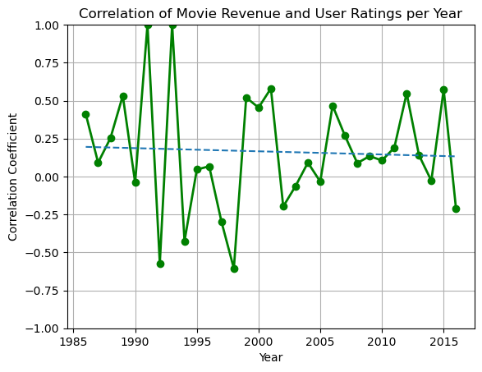

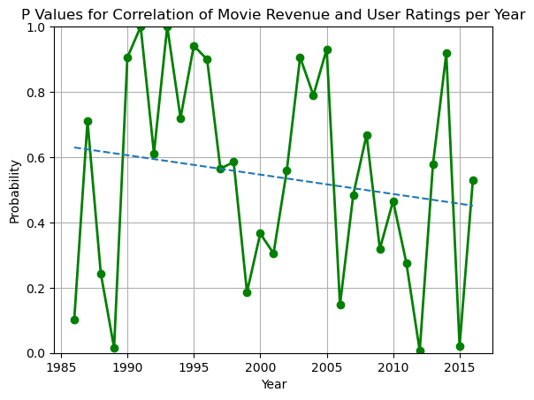

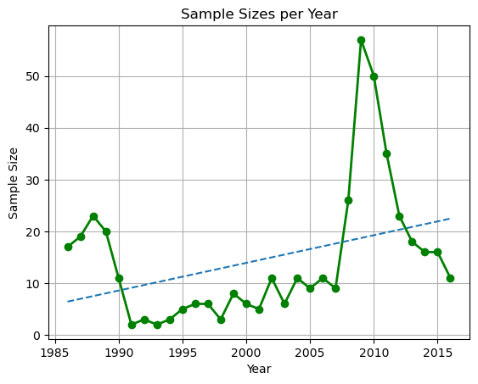

**F2 Practical Significance**

The practical significance of the results of this project lies in the proper assignment of value we each give to a movie’s user ratings. Many individuals base their purchases on the results of peer review, and this basis for determining the value of a product to you may be flawed. Each of us assesses a product based on another user’s ratings to some extent before purchasing that product. The goal of this project is to demonstrate if numerical user ratings are useful in determining the success of a product which in this case, the products are box office movies.

Given the results of this analysis of the relationship between movie ratings and movie revenue, it can be clearly understood that movie ratings should not be given much value in the decision-making process as they are not indicative of a movie’s success.

Given the subjective nature of reviews and ratings and the wide range of opinions regarding what makes a movie “good” or “bad”, it may be more useful to identify another means to predict the success of a film or any other product. Even seemingly factual results indicating that a product or movie met expectations are based on the expectations of the individual reviewer who may not reflect another’s mindset. The takeaway from this analysis is that user reviews should not be used to indicate a movie’s success.

**F3: Overall Success**

Based on the results of this analysis, the project was a success. The correlation coefficients and P values for each year of the sampled year range, 2006 to 2016, were recorded. Scatter plots representing the relationship of movie revenue and user ratings have been produced and bar charts demonstrating the revenue and user ratings of the top ten movies by user rating and revenue have been created. Additionally, trending for the correlation, probability, and sample sizes have been identified for movies released within the original ten-year period as well as for a broader thirty-year period.

**G: Conclusions**

**G1: Summary of Conclusions**

This project has identified that there is no significant relationship between a movie’s revenue and user ratings. In addition, the probability of no relationship existing between user ratings and movie revenue has been found more significant than our hypothesis that there is a correlation therein. User ratings are highly subjective and reflect a specific user’s mindset at the time of the review and should not be given much value when deciding whether to purchase a movie or any other product.

**G2: Effective Storytelling**

The scatterplots and bar charts represent the relationship between movie revenue and user ratings for each given year of the sample range, 2006 to 2016. These charts reflect the movie data for each year in a way that is easy to understand for any user.

The line charts of the correlation coefficients, P values, and sample sizes over the years of the sample period demonstrate the changes over time in this data in a way that is easily understood by any viewer.

**G3: Recommended Courses of Action**

Based on the results of this analysis a recommendation to review other factors related to the success of a movie should be explored. These other factors could include the number of theaters that showed these movies, the movie genre, actors, production costs, etc. An analysis using datasets that include a much wider range of data would likely lead to conclusions regarding where to focus such an analysis.

Another recommendation would be to break down sources of revenue for these movies such as box office openings, streaming services, cable TV broadcast, etc. Identifying the impact of user reviews specific to these sources of movie revenue could lead to insights regarding where user ratings may be most significant regards movie revenue.

**H: Panopto (Overview) Video Presentation**

Panopto Link: <https://wgu.hosted.panopto.com/Panopto/Pages/Viewer.aspx?id=15edd071-de90-485e-b1df-b24901553419>

**Appendices**

1. The code used for this analysis is stored in a GitHub repository.
2. GitHub link: [KennethExchange/Data-Analytics-Capstone at master](https://github.com/KennethExchange/Data-Analytics-Capstone/tree/master)

Note: The code is contained within the following file: D502 Capstone - Popular Movies Make More Money.ipynb

1. The two datasets selected for this project are public domain and are found on OpenML.org.

The two datasets are:

1. The Revenue dataset:

From OpenML: Detailed movie descriptions - ideal for Recommendation Engines Website: <https://www.openml.org/search?type=data&status=active&id=43113> Link to data: <https://www.openml.org/data/download/22047889/dataset>

1. The Review dataset:

From OpenML: This dataset contains IMDb ratings and votes information for movies having original titles. Website: <https://www.openml.org/search?type=data&sort=runs&id=43784&status=active> Link to data: <https://www.openml.org/data/download/22102609/dataset>

**References**

None